**HASIL OLAH DATA PLS**

Gambar Outer Model dengan *Factor Loading,*  *Path Coefficient* dan *R-Square*

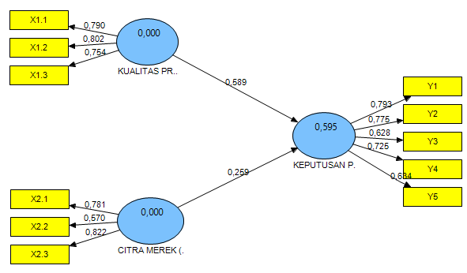

Gambar Inner Model dengan nilai signifikansi *T-Statistic* *Bootstraping*

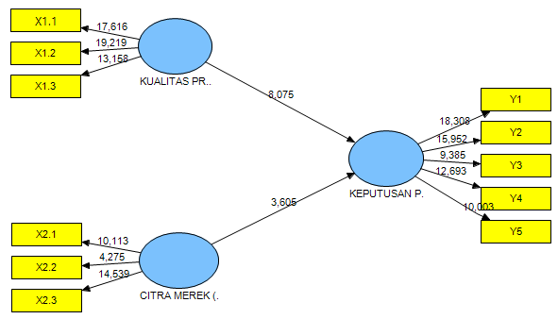

**Path Coefficients (Mean, STDEV, T-Values)**

|  |  |  |  |  |  |
| --- | --- | --- | --- | --- | --- |
|  | **Path Coefficients (O)** | **Sample Mean (M)** | **Standard Deviation (STDEV)** | **Standard Error (STERR)** | **T Statistics (|O/STERR|)** |
| **KUALITAS PRODUK (X1) -> KEPUTUSAN PEMBELIAN (Y)** | 0,589003 | 0,584648 | 0,072946 | 0,072946 | 8,074526 |
| **CITRA MEREK (X2) -> KEPUTUSAN PEMBELIAN (Y)** | 0,258514 | 0,267172 | 0,071703 | 0,071703 | 3,605330 |

**Outer Weights (Mean, STDEV, T-Values)**

|  |  |  |  |  |  |
| --- | --- | --- | --- | --- | --- |
|  | **Original Sample (O)** | **Sample Mean (M)** | **Standard Deviation (STDEV)** | **Standard Error (STERR)** | **T Statistics (|O/STERR|)** |
| **X1.1 <- KUALITAS PRODUK (X1)** | 0,473117 | 0,476225 | 0,043789 | 0,043789 | 10,804490 |
| **X1.2 <- KUALITAS PRODUK (X1)** | 0,437065 | 0,444612 | 0,031454 | 0,031454 | 13,895188 |
| **X1.3 <- KUALITAS PRODUK (X1)** | 0,365435 | 0,363233 | 0,042862 | 0,042862 | 8,525743 |
| **X2.1 <- CITRA MEREK (X2)** | 0,390593 | 0,379954 | 0,068525 | 0,068525 | 5,700033 |
| **X2.2 <- CITRA MEREK (X2)** | 0,378957 | 0,363082 | 0,080692 | 0,080692 | 4,696356 |
| **X2.3 <- CITRA MEREK (X2)** | 0,582806 | 0,603778 | 0,111050 | 0,111050 | 5,248146 |
| **Y1 <- KEPUTUSAN PEMBELIAN (Y)** | 0,301865 | 0,307957 | 0,028358 | 0,028358 | 10,644741 |
| **Y2 <- KEPUTUSAN PEMBELIAN (Y)** | 0,294605 | 0,294855 | 0,025556 | 0,025556 | 11,527673 |
| **Y3 <- KEPUTUSAN PEMBELIAN (Y)** | 0,262367 | 0,267699 | 0,032988 | 0,032988 | 7,953446 |
| **Y4 <- KEPUTUSAN PEMBELIAN (Y)** | 0,282143 | 0,281138 | 0,030402 | 0,030402 | 9,280315 |
| **Y5 <- KEPUTUSAN PEMBELIAN (Y)** | 0,256962 | 0,257551 | 0,029367 | 0,029367 | 8,749895 |

**Outer Loadings (Mean, STDEV, T-Values)**

|  |  |  |  |  |  |
| --- | --- | --- | --- | --- | --- |
|  | **Factor Loading (O)** | **Sample Mean (M)** | **Standard Deviation (STDEV)** | **Standard Error (STERR)** | **T Statistics (|O/STERR|)** |
| **X1.1 <- KUALITAS PRODUK (X1)** | 0,789955 | 0,783472 | 0,044843 | 0,044843 | 17,616128 |
| **X1.2 <- KUALITAS PRODUK (X1)** | 0,802418 | 0,799367 | 0,041750 | 0,041750 | 19,219484 |
| **X1.3 <- KUALITAS PRODUK (X1)** | 0,754035 | 0,741444 | 0,057304 | 0,057304 | 13,158427 |
| **X2.1 <- CITRA MEREK (X2)** | 0,780737 | 0,758398 | 0,077201 | 0,077201 | 10,112993 |
| **X2.2 <- CITRA MEREK (X2)** | 0,570452 | 0,531943 | 0,133434 | 0,133434 | 4,275173 |
| **X2.3 <- CITRA MEREK (X2)** | 0,821667 | 0,830191 | 0,056514 | 0,056514 | 14,539052 |
| **Y1 <- KEPUTUSAN PEMBELIAN (Y)** | 0,792984 | 0,789080 | 0,043313 | 0,043313 | 18,308339 |
| **Y2 <- KEPUTUSAN PEMBELIAN (Y)** | 0,774841 | 0,765685 | 0,048573 | 0,048573 | 15,951944 |
| **Y3 <- KEPUTUSAN PEMBELIAN (Y)** | 0,628219 | 0,625212 | 0,066942 | 0,066942 | 9,384559 |
| **Y4 <- KEPUTUSAN PEMBELIAN (Y)** | 0,724989 | 0,713674 | 0,057117 | 0,057117 | 12,693127 |
| **Y5 <- KEPUTUSAN PEMBELIAN (Y)** | 0,634253 | 0,623168 | 0,063405 | 0,063405 | 10,003197 |

**Latent Variable Correlations**

|  |  |  |  |
| --- | --- | --- | --- |
|  | **CITRA MEREK (X2)** | **KEPUTUSAN PEMBELIAN (Y)** | **KUALITAS PRODUK (X1)** |
| **CITRA MEREK (X2)** | 1,000000 |  |  |
| **KEPUTUSAN PEMBELIAN (Y)** | 0,608426 | 1,000000 |  |
| **KUALITAS PRODUK (X1)** | 0,594076 | 0,742579 | 1,000000 |

**R Square**

|  |  |
| --- | --- |
|  | **R Square** |
| **CITRA MEREK (X2)** |  |
| **KEPUTUSAN PEMBELIAN (Y)** | 0,594668 |
| **KUALITAS PRODUK (X1)** |  |

**Cross Loading**

|  |  |  |  |
| --- | --- | --- | --- |
|  | **CITRA MEREK (X2)** | **KEPUTUSAN PEMBELIAN (Y)** | **KUALITAS PRODUK (X1)** |
| **X1.1** | 0,586807 | 0,640631 | 0,789955 |
| **X1.2** | 0,416022 | 0,591814 | 0,802418 |
| **X1.3** | 0,368380 | 0,494822 | 0,754035 |
| **X2.1** | 0,780737 | 0,373756 | 0,304678 |
| **X2.2** | 0,570452 | 0,362622 | 0,438635 |
| **X2.3** | 0,821667 | 0,557683 | 0,529930 |
| **Y1** | 0,500620 | 0,792984 | 0,556985 |
| **Y2** | 0,454884 | 0,774841 | 0,558377 |
| **Y3** | 0,447423 | 0,628219 | 0,478703 |
| **Y4** | 0,405918 | 0,724989 | 0,547805 |
| **Y5** | 0,355613 | 0,634253 | 0,505090 |

**AVE**

|  |  |
| --- | --- |
|  | **AVE** |
| **CITRA MEREK (X2)** | 0,536701 |
| **KEPUTUSAN PEMBELIAN (Y)** | 0,510350 |
| **KUALITAS PRODUK (X1)** | 0,612157 |

**Composite Reliability**

|  |  |
| --- | --- |
|  | **Composite Reliability** |
| **CITRA MEREK (X2)** | 0,772566 |
| **KEPUTUSAN PEMBELIAN (Y)** | 0,837738 |
| **KUALITAS PRODUK (X1)** | 0,825536 |