**HASIL OLAH DATA PLS**

Gambar Outer Model dengan *Factor Loading,*  *Path Coefficient* dan *R-Square*

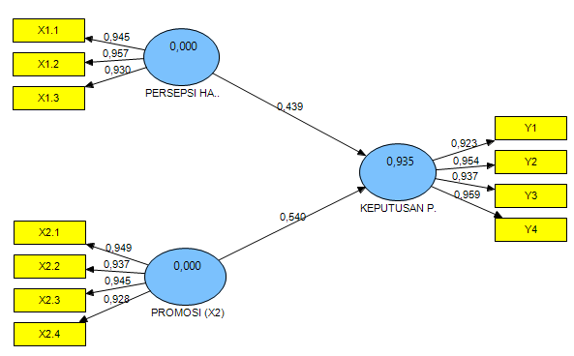

Gambar Inner Model dengan nilai signifikansi *T-Statistic* *Bootstraping*

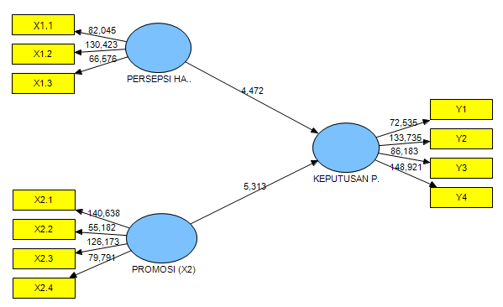

**Path Coefficients (Mean, STDEV, T-Values)**

|  |  |  |  |  |  |
| --- | --- | --- | --- | --- | --- |
|  | **Path Coefficients (O)** | **Sample Mean (M)** | **Standard Deviation (STDEV)** | **Standard Error (STERR)** | **T Statistics (|O/STERR|)** |
| **PERSEPSI HARGA (X1) -> KEPUTUSAN PEMBELIAN (Y)** | 0,439309 | 0,437897 | 0,098239 | 0,098239 | 4,471828 |
| **PROMOSI (X2) -> KEPUTUSAN PEMBELIAN (Y)** | 0,540295 | 0,541614 | 0,101692 | 0,101692 | 5,313026 |

**Outer Weights (Mean, STDEV, T-Values)**

|  |  |  |  |  |  |
| --- | --- | --- | --- | --- | --- |
|  | **Original Sample (O)** | **Sample Mean (M)** | **Standard Deviation (STDEV)** | **Standard Error (STERR)** | **T Statistics (|O/STERR|)** |
| **X1.1 <- PERSEPSI HARGA (X1)** | 0,345638 | 0,345797 | 0,005394 | 0,005394 | 64,080246 |
| **X1.2 <- PERSEPSI HARGA (X1)** | 0,356170 | 0,356491 | 0,006480 | 0,006480 | 54,963467 |
| **X1.3 <- PERSEPSI HARGA (X1)** | 0,357344 | 0,358114 | 0,007895 | 0,007895 | 45,263900 |
| **X2.1 <- PROMOSI (X2)** | 0,269427 | 0,269620 | 0,004445 | 0,004445 | 60,608701 |
| **X2.2 <- PROMOSI (X2)** | 0,263906 | 0,263777 | 0,004288 | 0,004288 | 61,550385 |
| **X2.3 <- PROMOSI (X2)** | 0,272695 | 0,272938 | 0,004704 | 0,004704 | 57,975505 |
| **X2.4 <- PROMOSI (X2)** | 0,257953 | 0,258169 | 0,004076 | 0,004076 | 63,288705 |
| **Y1 <- KEPUTUSAN PEMBELIAN (Y)** | 0,260943 | 0,260777 | 0,002922 | 0,002922 | 89,290005 |
| **Y2 <- KEPUTUSAN PEMBELIAN (Y)** | 0,263361 | 0,263568 | 0,002991 | 0,002991 | 88,055990 |
| **Y3 <- KEPUTUSAN PEMBELIAN (Y)** | 0,263785 | 0,263634 | 0,003255 | 0,003255 | 81,037589 |
| **Y4 <- KEPUTUSAN PEMBELIAN (Y)** | 0,271694 | 0,271973 | 0,003497 | 0,003497 | 77,699559 |

**Outer Loadings (Mean, STDEV, T-Values)**

|  |  |  |  |  |  |
| --- | --- | --- | --- | --- | --- |
|  | **Factor Loading (O)** | **Sample Mean (M)** | **Standard Deviation (STDEV)** | **Standard Error (STERR)** | **T Statistics (|O/STERR|)** |
| **X1.1 <- PERSEPSI HARGA (X1)** | 0,945072 | 0,943710 | 0,011519 | 0,011519 | 82,045212 |
| **X1.2 <- PERSEPSI HARGA (X1)** | 0,957083 | 0,956756 | 0,007338 | 0,007338 | 130,423479 |
| **X1.3 <- PERSEPSI HARGA (X1)** | 0,930372 | 0,928863 | 0,013975 | 0,013975 | 66,575726 |
| **X2.1 <- PROMOSI (X2)** | 0,948749 | 0,948036 | 0,006746 | 0,006746 | 140,638251 |
| **X2.2 <- PROMOSI (X2)** | 0,937222 | 0,936317 | 0,016984 | 0,016984 | 55,182333 |
| **X2.3 <- PROMOSI (X2)** | 0,945246 | 0,945347 | 0,007492 | 0,007492 | 126,173123 |
| **X2.4 <- PROMOSI (X2)** | 0,927609 | 0,927123 | 0,011625 | 0,011625 | 79,791003 |
| **Y1 <- KEPUTUSAN PEMBELIAN (Y)** | 0,923243 | 0,923085 | 0,012728 | 0,012728 | 72,535083 |
| **Y2 <- KEPUTUSAN PEMBELIAN (Y)** | 0,954304 | 0,954302 | 0,007136 | 0,007136 | 133,735185 |
| **Y3 <- KEPUTUSAN PEMBELIAN (Y)** | 0,937058 | 0,936591 | 0,010873 | 0,010873 | 86,182988 |
| **Y4 <- KEPUTUSAN PEMBELIAN (Y)** | 0,959087 | 0,959064 | 0,006440 | 0,006440 | 148,920554 |

**Latent Variable Correlations**

|  |  |  |  |
| --- | --- | --- | --- |
|  | **KEPUTUSAN PEMBELIAN (Y)** | **PERSEPSI HARGA (X1)** | **PROMOSI (X2)** |
| **KEPUTUSAN PEMBELIAN (Y)** | 1,000000 |  |  |
| **PERSEPSI HARGA (X1)** | 0,951271 | 1,000000 |  |
| **PROMOSI (X2)** | 0,956567 | 0,947562 | 1,000000 |

**R Square**

|  |  |
| --- | --- |
|  | **R Square** |
| **KEPUTUSAN PEMBELIAN (Y)** | 0,934729 |
| **PERSEPSI HARGA (X1)** |  |
| **PROMOSI (X2)** |  |

**Cross Loading**

|  |  |  |  |
| --- | --- | --- | --- |
| **INDIKATOR** | **KEPUTUSAN PEMBELIAN (Y)** | **PERSEPSI HARGA (X1)** | **PROMOSI (X2)** |
| **X1.1** | 0,879090 | 0,945072 | 0,876556 |
| **X1.2** | 0,905878 | 0,957083 | 0,893418 |
| **X1.3** | 0,908865 | 0,930372 | 0,913355 |
| **X2.1** | 0,910241 | 0,889897 | 0,948749 |
| **X2.2** | 0,891587 | 0,913400 | 0,937222 |
| **X2.3** | 0,921280 | 0,908498 | 0,945246 |
| **X2.4** | 0,871476 | 0,849013 | 0,927609 |
| **Y1** | 0,923243 | 0,874427 | 0,896419 |
| **Y2** | 0,954304 | 0,887177 | 0,900947 |
| **Y3** | 0,937058 | 0,911296 | 0,883946 |
| **Y4** | 0,959087 | 0,916699 | 0,928274 |

**AVE**

|  |  |
| --- | --- |
|  | **AVE** |
| **KEPUTUSAN PEMBELIAN (Y)** | 0,890250 |
| **PERSEPSI HARGA (X1)** | 0,891587 |
| **PROMOSI (X2)** | 0,883114 |

**Composite Reliability**

|  |  |
| --- | --- |
|  | **Composite Reliability** |
| **KEPUTUSAN PEMBELIAN (Y)** | 0,970095 |
| **PERSEPSI HARGA (X1)** | 0,961042 |
| **PROMOSI (X2)** | 0,967968 |